**Purpose**

This document provides an overview of east-west traffic patterns within Google Cloud Platform (GCP), focusing on how traffic flows between resources in the same network, best practices for managing and securing this traffic, and GCP services that facilitate these patterns.

**Table of Contents**

**Introduction to East-West Traffic**

* Definition
* Importance in Microservices Architectures
* Common Use Cases in GCP

**Designing for East-West Traffic**

* Shared VPCs
* Load Balancing for Internal Traffic
* Service Networking
* Secure East-West Traffic
* Microservices and Service Mesh
* Monitor and Log Traffic

**Securing East-West Traffic**

* Firewall Rules and IAM Policies
* Private Google Access
* VPC Service Controls
* Cloud Armor for Internal Traffic
* Mutual TLS (mTLS) and Zero Trust

**Scaling East-West Traffic**

* Auto-scaling in GKE
* Instance Groups and Load Balancing
* Horizontal Pod Autoscaling (HPA)
* Global Load Balancers and Traffic Director

**Use cases**

* Example Architecture for a Microservices Application
* Internal API Communication
* Multi-Region Deployment Scenarios

**Introduction to East-West Traffic**

Definition

East-west traffic refers to the flow of data between internal components within the same network, typically within the same cloud environment or data centre. In GCP, this involves communication between virtual machines (VMs), containers, or services within a Virtual Private Cloud (VPC).

Importance in Microservices Architectures

In modern cloud-native applications, particularly those using microservices, east-west traffic is predominant. Efficient management of this traffic is crucial for ensuring low latency, high availability, and secure communication between services.

Common Use Cases in GCP

1. Microservices Architecture - Inter-service communication within a Kubernetes cluster (GKE).
2. Data replication between databases or storage services.
3. Data Processing Pipeline.
4. Multi-Region Application Deployment.
5. Secure Internal API Gateway.
6. Communication to Google managed services via Private Service Connect.

**Use Case 1: Microservices Architecture -** Inter-service communication within a Kubernetes cluster (GKE)

**Scenario:**  
A cloud-native application is built using a microservices architecture where each microservice performs a specific function and communicates with other microservices over the network.

**East-West Traffic Details:**

* **Inter-Service Communication:** Microservices within the same Virtual Private Cloud (VPC) communicate with each other over internal IP addresses. This internal traffic is considered east-west traffic.
* **Traffic Patterns:** High frequency of small, low-latency messages between microservices, often using gRPC or HTTP/2 protocols.

**Challenges:**

* **Centralized Network Management:** Microservices are generally deployed by multiple teams handling their own resources and projects to spin up services.
* **Isolated Projects with Centralized Control:** Multiple teams having multiple projects and VPCs for their resources for hosting services.
* **Seamless Inter-Project Communication:** Need to establish private and fast connectivity between multiple VPCs.
* **Peering Limits:** In case of large-scale, multi-project environments, VPCs will need to be peered to enable fast connectivity and reduce latency. There is a hard limit of 25 VPC peering in GCP.
* **Private IPv4 addresses exhaustion:** IP space is limited for ever growing need of microservices.
* **Regulation of network access:** Isolated Projects with Centralized Control is complex in case of large-scale deployments.
* **In-Consistent DNS and Growing Routing:** Growing microservices deployment will pose a challenge in terms of fast DNS resolution and routing table limitations.

**Solution:**

**Use Shared VPC Model:**

* **Shared VPC:** Allows to centralize the management of your network infrastructure. The network administrator can manage the VPC, subnets, and firewall rules from a single location, reducing complexity
* **Consistent Policies:** Implement consistent security policies, such as firewall rules and routes, across multiple projects from a central point, ensuring uniformity and compliance
* **Efficient Use of Resources:** Shared VPC allows for more efficient use of network resources like subnets and IP ranges, reducing wastage.
* **Low Latency:** Internal communication between resources in different projects within a Shared VPC is direct and fast, without the latency that might be introduced by VPC peering or external routes.
* **Optimized Traffic Routing:** Traffic between resources in the same Shared VPC is routed internally within Google’s network, optimizing performance and reducing latency compared to external routing.
* **Minimized Configuration Complexity:** Shared VPC reduces the need for complex VPC peering configurations and simplifies network administration, reducing the operational overhead for managing large, multi-project environments.
* **Streamlined Network Changes:** Changes to the network, such as modifying firewall rules or adding subnets, can be made centrally and will automatically apply across all projects using the Shared VPC.

**Implement Service Mesh:**

* Use Traffic Director with Istio to manage the traffic between microservices, providing fine-grained control over routing, load balancing, and retries.
* **Intelligent Routing:** Service mesh provides advanced traffic routing capabilities, such as canary releases, A/B testing, and blue-green deployments, allowing for gradual rollouts and easy rollbacks.
* **Load Balancing:** Service mesh offers sophisticated load balancing strategies, such as round-robin, least connection, and weighted routing, optimizing how traffic is distributed among service instances.
* **Traffic Shaping:** You can define policies for shaping traffic, such as rate limiting, throttling, and retries, which helps in preventing overloads and managing traffic spikes.

**Implement Internal Load Balancing:**

* Deploy internal load balancers to distribute traffic among instances of the same microservice, ensuring high availability and resilience.
* **Private IP Addresses:** Internal load balancing uses private IP addresses, ensuring that your traffic stays within your Virtual Private Cloud (VPC) network and isn’t exposed to the public internet.
* **Auto-scaling Support:** Internal load balancers can work seamlessly with GKE’s auto-scaling capabilities, adjusting the number of backend instances based on traffic demand without manual intervention.

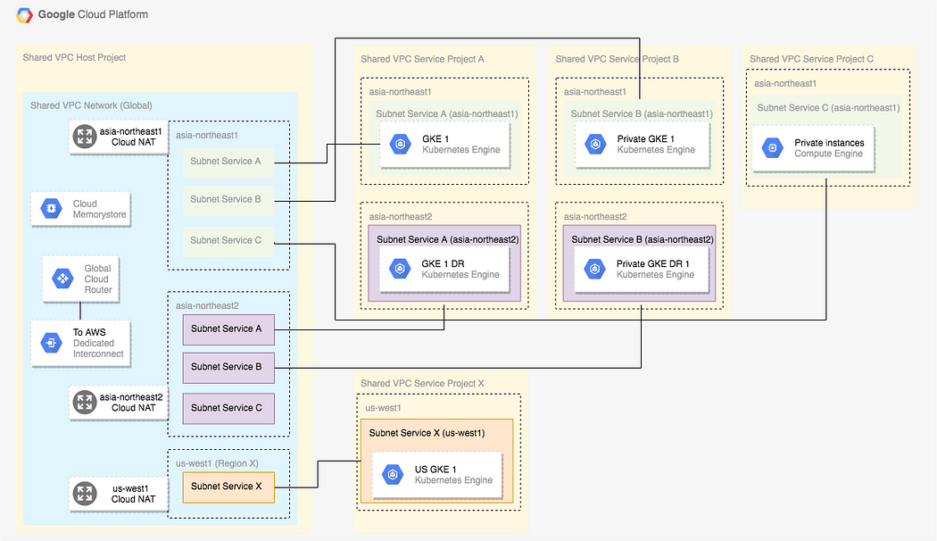

**Use Case 2: Data Processing Pipeline**

**Scenario:**  
An organization has a big data processing pipeline where different stages of processing (e.g., data ingestion, transformation, analysis) are handled by separate services deployed within the same network.

**East-West Traffic Details:**

* **Stage-to-Stage Communication:** Data flows between different stages of the pipeline, typically involving large datasets that need to be transferred and processed internally.
* **Traffic Patterns:** High volume of data transfer between services like Apache Kafka, Apache Spark, and BigQuery.

**Solution:**

* **Optimized Networking:** Use VPC peering or Shared VPCs to ensure that data flows efficiently between different processing stages, minimizing latency and maximizing throughput.
* **Internal Load Balancing:** Implement internal load balancers to distribute the workload evenly across processing nodes, ensuring optimal resource utilization.
* **Firewall Rules:** Configure fine-grained firewall rules to control which services can communicate with each other, enhancing security without sacrificing performance.

**Use Case 3: Hybrid Cloud Environment**

**Scenario:**  
A business operates a hybrid cloud environment where on-premises systems need to interact with services running in GCP, such as databases, analytics platforms, and machine learning models.

**East-West Traffic Details:**

* **On-Premises to Cloud Communication:** Data is exchanged between on-premises systems and GCP resources within a single network.
* **Traffic Patterns:** Periodic or continuous data synchronization between on-premises databases and cloud-hosted databases.

**Solution:**

* **VPC Peering/Cloud Interconnect:** Use VPC peering or Cloud Interconnect to establish secure, low-latency connections between on-premises systems and GCP, allowing seamless internal traffic.
* **Private Google Access:** Ensure that on-premises systems can access GCP services without exposing traffic to the public internet, using Private Google Access.
* **Data Encryption:** Encrypt all traffic between on-premises and cloud resources to protect sensitive data in transit.

**Use Case 4: Multi-Region Application Deployment**

**Scenario:**  
An enterprise deploys an application across multiple GCP regions for high availability and disaster recovery, with internal components needing to communicate across regions.

**East-West Traffic Details:**

* **Cross-Region Communication:** Services deployed in different regions must communicate with each other internally, such as for database replication or failover mechanisms.
* **Traffic Patterns:** Frequent replication and synchronization of data between regions to ensure consistency and availability.

**Solution:**

* **Global Load Balancing:** Utilize GCP’s global load balancers to manage and route traffic efficiently between services in different regions.
* **VPC Peering:** Establish VPC peering connections between the different regions to facilitate secure and efficient east-west traffic.
* **Latency Optimization:** Use Google Cloud’s high-performance backbone network to minimize latency and ensure fast communication between regions.

**Use Case 5: Secure Internal API Gateway**

**Scenario:**  
A company needs to manage internal APIs that are only accessible to services within the same network, ensuring secure and efficient communication between internal components.

**East-West Traffic Details:**

* **Internal API Communication:** Microservices or applications communicate via APIs that are hosted internally, and not exposed to the internet.
* **Traffic Patterns:** Frequent API calls within the VPC, possibly involving authentication and authorization checks.

**Solution:**

* **Internal HTTP(S) Load Balancer:** Deploy an internal HTTP(S) load balancer to manage API traffic, providing secure and scalable API access within the VPC.
* **API Gateway:** Implement a GCP API Gateway to control and monitor API traffic, applying security policies, quotas, and rate limits to protect against abuse.
* **Service Accounts and IAM Roles:** Use service accounts with appropriate IAM roles to manage access to internal APIs, ensuring that only authorized services can make requests.

**Designing for East-West Traffic [ Target State ]**

• **VPC Setup:** Create a VPC with subnets in different availability zones for your microservices and databases.

• **Internal Load Balancer:** Use an internal HTTP(S) load balancer to manage traffic between the frontend and backend services.

• **Service Mesh:** Deploy Istio to manage traffic routing, enforce security policies, and gain visibility into service-to-service communication.

• **VPC Peering:** If your application spans multiple VPCs (e.g., different environments like dev, staging, and prod), set up VPC peering to enable communication across these environments.

• **Private Google Access:** Ensure that all services can access Google Cloud APIs securely without the need for external IPs.

2. GCP Networking Basics

VPC Overview

A Virtual Private Cloud (VPC) is a fundamental concept in GCP, providing a private network space where you can run your services securely and isolated from other networks.

Subnets and Regions

• Subnets allow you to segment your VPC into smaller networks.

• GCP allows you to create regional or custom subnets, depending on your architecture needs.

Firewalls and Security Policies

• Firewall Rules: Control the flow of traffic into and out of your VPC networks.

• IAM Policies: Manage who can create, modify, or view firewall rules.

Routing and Peering

• VPC Peering: Enables you to connect VPC networks to facilitate internal communication.

• Custom Routes: Used to direct traffic within your VPCs.

3. Designing for East-West Traffic

Microservices and Service Mesh

• Implementing a service mesh (e.g., Istio) allows you to manage and monitor east-west traffic, offering features like load balancing, encryption, and traffic policies.

Kubernetes Engine (GKE) Internal Traffic

• Cluster Networking: GKE uses VPC-native clusters to handle internal traffic with minimal latency.

• Internal Load Balancers: Designed for east-west traffic, they route traffic within the VPC.

Load Balancing for Internal Traffic

• Internal Load Balancers: Used for distributing traffic among instances within the same VPC.

• Traffic Director: Provides global traffic management for microservices.

VPC Peering and Shared VPCs

• VPC Peering: Useful for connecting multiple VPCs across different projects.

• Shared VPC: Allows multiple projects to share the same VPC network.

Service Networking

• Private Service Connect: Enables private communication between your VPC and Google services or third-party services.

4. Securing East-West Traffic

Firewall Rules and IAM Policies

• Ensure strict control over which instances or services can communicate internally.

• Use IAM policies to manage access to networking components.

Private Google Access

• Enables instances without external IPs to reach Google services via internal IP addresses.

VPC Service Controls

• Provides additional security by creating service perimeters to protect your data and services.

Cloud Armor for Internal Traffic

• While typically used for external traffic, Cloud Armor can also be configured for east-west traffic scenarios to protect against threats.

Mutual TLS (mTLS) and Zero Trust

• Implement mTLS to ensure that all internal service communications are encrypted and authenticated.

• Adopt a Zero Trust model to continually validate access and trustworthiness.

5. Monitoring and Optimizing East-West Traffic

Network Monitoring Tools in GCP

• VPC Flow Logs: Monitor and analyze the flow of traffic within your VPC.

• Cloud Trace: Track the performance of services to identify latency issues.

Stackdriver Logging and Monitoring

• Use Stackdriver to log and monitor east-west traffic, providing insights into performance and security.

Network Intelligence Center

• A tool to visualize and understand your network topology, and to troubleshoot networking issues.

Traffic Optimization Techniques

• Implement caching and compression to reduce load on your services.

• Optimize routes and use load balancing to ensure efficient traffic flow.

Handling Traffic Spikes and Load Distribution

• Scale services automatically using GKE’s autoscaling features.

• Use internal load balancers to distribute traffic evenly across instances.

6. Scaling East-West Traffic

Auto-scaling in GKE

• Horizontal Pod Autoscaling (HPA) allows your Kubernetes cluster to automatically scale based on metrics like CPU or memory usage.

Instance Groups and Load Balancing

• Use managed instance groups with auto-scaling enabled to handle increased east-west traffic.

Horizontal Pod Autoscaling (HPA)

• Dynamically adjust the number of pods in your GKE cluster to handle varying traffic loads.

Global Load Balancers and Traffic Director

• Traffic Director provides managed traffic control for microservices across multiple regions.

7. Case Studies and Examples

Example Architecture for a Microservices Application

• Detailed diagram and explanation of a typical microservices setup in GCP with east-west traffic patterns.

Best Practices for Internal API Communication

• Strategies for efficient API communication, including caching, batching, and error handling.

Multi-Region Deployment Scenarios

• Guidance on deploying services across multiple regions while managing east-west traffic effectively.

8. Conclusion

Summary of Best Practices

• Ensure secure, scalable, and efficient east-west traffic management by following GCP best practices.

Key Considerations for East-West Traffic in GCP

• Security, scalability, performance, and cost are the main factors to consider when managing internal traffic.

Further Reading and Resources

• Links to GCP documentation, whitepapers, and relevant blogs for in-depth understanding.

This documentation provides a comprehensive guide to understanding, designing, securing, monitoring, and scaling east-west traffic patterns in GCP. It’s essential to tailor these sections to your organization’s specific use cases and requirements.

**6.2. Further Reading**

* Google Cloud Networking Overview
* VPC Documentation
* Traffic Director Documentation